Om

**IMPORTANCE OF GUNAS IN PREDICTON**

Prof.Hemalatha A.Krishnan PhD

.

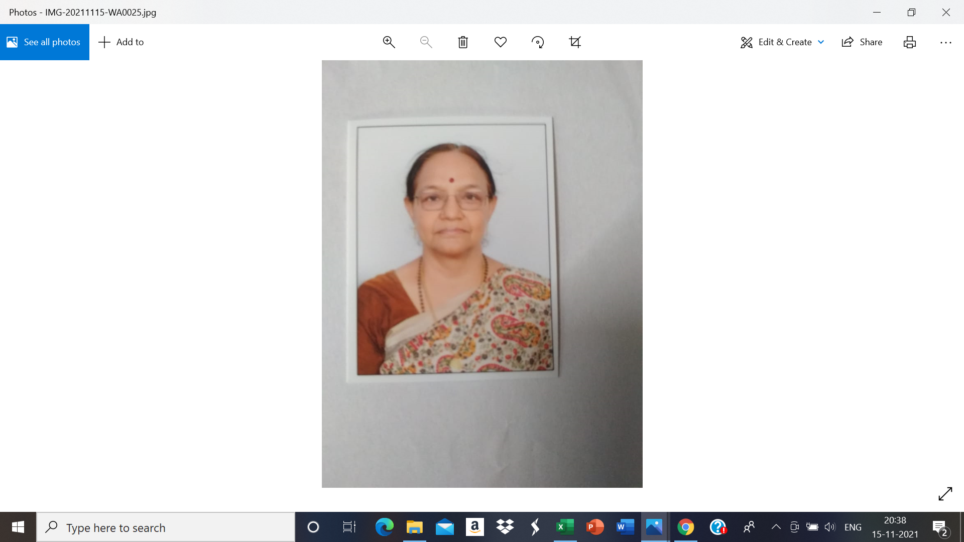

*Prof. Hemalatha A.Krishnan,a disciple of Prof N V R A Raja, is a Sr.faculty at JKR astro research foundation since its inception in 2011.A banker by profession, she is passionate about teaching the unique findings of Guruji Sri N V Raghavachary and is totally committed to spread Meena 2 Nakshatra Sidhantham. Pursuing her interest in research, she did PhD in the stellar concept of Uttamadrekkana. She has contributed numerous articles in magazines and given many presentations in various seminars. She is serving society by rendering free services in predictions to guide and counsel the seekers. In recognition of her services she has been conferred upon several honorary titles like Jyotisha kalanidhi,Daivagna Vallabha ,jyothisha choodamani and so on* . **hemalatha1308@gmail.com**

GURUJI ACHARYASRI SRI N V RAGHAVACHARY, MEENA 2 , A PIONEER IN NAKSHATRA SIDDHANTHAM HAS GIVEN A NOVEL APPROACH TO PREDICTIVE ASTROLOGY USING GUNAS. AN ANALYSIS BASED ON THE GUNAS ACQUIRED BY THE PLANETS GIVES A DEEP INSIGHT INTO THE QUALITY, INTENSITY OF THE RESULTS DELIVERED BY THEM AND THE TIMING OF EVENTS.

In the philosophy of yoga, all matter in the universe arises from Prakriti and from this emerge the three GUNAS creating the essential aspects of all nature-energy, matter and consciousness. The 3 Gunas are SATTWA: quality of harmony,goodness,purity,positive,peaceful;RAJASA:passion,activity,dynamic,desires,

egoism and TAMASA: imbalance, delusion, inertia, chaotic, destructive.

Planets are part of Prakriti and hence they also have inherent Gunas .On the basis of their predominant traits and mode of behaviour the planets are classified as

**SAATWIC PLANETS**: JUPITER,MERCURY ,**RAJASIC PLANETS**:SUN,MOON,VENUS

**TAMASIC PLANETS**: MARS,SATURN,RAHU,KETU.

The GUNAS are to be judged by the location of the planets in various constellations,. The inherent Guna of a Planet undergoes various changes in conformity with its motion, the constellation in which it is placed or situated and also by its occupation of the particular portion or part of the Zodiac.

The GUNAS acquired by the planets themselves are capable of endowing certain results to the native. As the first Guna the planet acquires the Guna of the Constellation lord in which it is posited.

SRI N V RAGHAVACHARY says planets should acquire their own guna for beneficial results i.e. a Saatwic planet should acquire Satwic Guna, a Rajasic planet should get Rajasic and a Thamasic planet should get Thamasic Guna. Mixed results follow when a Satwic planet gets Rajasic guna and when a Rajasic planet gets Satwic guna .Proper results may not be the outcome when a Rajasic planet gets thamasic, a thamasic planet gets Rajasic and a Satwic planet gets thamasic guna.

We shall look into this concept with an example

Sangeet Marthand PANDIT JASRAJ was an exponent of Indian classical vocal music. Pandit Jasraj is the recipient of numerous awards and titles including the prestigious Padma Vibhushan in 2000. With his masterly virtuosity and incomparable velvet clad voice, he is the torch bearer of the Mewati Gharana. He has done extensive research in Haveli Sangeet and composed rare compositions in the devotional genre .As a tribute for the 8 decades of his intoxicating music ,the international astronomical union has named an asteroid or minor planet between mars and Jupiter after him in Nov 2006.

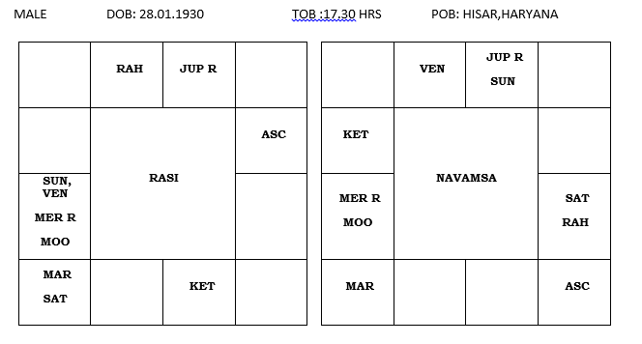

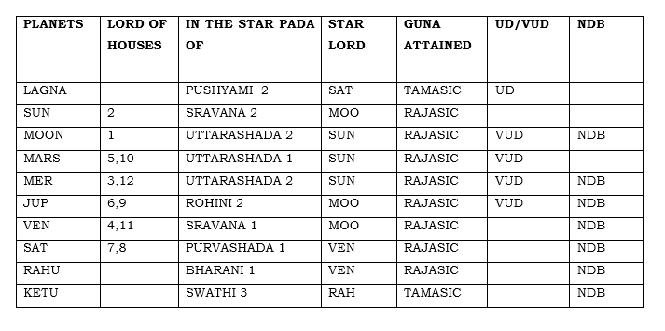

|  |
| --- |
| **UD**: UTTAMADREKKANA, **VUD**: VARGOTHAMA UTTAMADREKKANA  **NDB**: NAKSHATRA DIGBALA, **YOGAKARAKA**-JUPITER  **GUNAS**: SUN, MOON, VENUS – **RAJASIC** : JUPITER, MERCURY-**SAATWIC** :RAHU,KETU,MARS,SATURN-**TAMASIC** |

The Lagna is Cancer, a movable and watery sign. The native is enterprising, loves music, is original and inventive with imaginative powers. The Lagnapada is in Cancer in Pushyami 2 in Uttamadrekkana.

The Lagna lord Moon, a Rajasic planet is posited in the 7th house, a Kendra in Uttarashada 2, Rajasa vargothama Uttamadrekkana in the star of Sun.

When the lagnapada and the lagna lord are in Uttamadrekkana, connected to good houses, such a native is prominent in life, famous, powerful, commanding respect in society -- Sri N.V Raghavachary

The Lagna lord Moon gets nakshatra Digbala, being with the 4th lord Venus and is aspected by yoga karaka ,the 9th lord, Jupiter from the 11th house.

The lagna is aspected by Sun, the 2nd Lord, Venus, the lord of the 4th and the 11th houses, Mercury, the lord of the 2nd and the 12th houses, Mars, the lord of the 5th and the 10th houses and Moon, the lagna lord himself. The lagna is also aspected by the yoga karaka Jupiter, by reflection theory, one of the special concepts of Meena 2 Naadi system as propounded by Dr. N V R A Raja Meena 2 Jr. Jupiter from the 11th house aspects the planets in the 7th house, and they, in turn aspect the Lagna.

Hence, a strong Lagna with favorable connections to good houses and desirable Guna has made the native a notable personality and bestowed long life on the native. He passed away at the age of 90 in Aug 2020.He was very active, travelling worldwide, giving concerts and has acquired a legendary status.

The 2nd Lord Sun, who is also the karaka for name, fame and status is a Rajasic planet posited in the star of Sravana ,the lord being a Rajasic planet the moon. The native has a melodious and captivating voice. His penetratingly tuneful and distinctive voice traverses a remarkable range of four and a half octaves and lingers in every heart with perfect diction, clarity in sur and command in all aspects of laya and rhythm.

There is sookshma nakshatra parivartana between the 1st and 2nd lords. Moon, the lagnalord, is in the star of Sun, the 2nd lord and Sun, the 2nd lord is in the star of the Moon, the lagna lord. The Lagna lord, Moon himself gives the results of Sun, name, fame status and Sun gives the results of the lagna lord.

Both the luminaries are strong with a desirable Rajasic guna

The 3rd lord Mercury is posited in the 7th house in Uttarashada 2, vargothama Uttamadrekkana in the star of Sun. A Satwic planet Mercury gets a Rajasic guna. Mercury gets nakshatra Digbala, being posited with the lagna lord Moon. A strong Mercury is conjoined with the lagna lord Moon, Venus the lord of the 4th and the 11th houses and karaka for music and creativity and Sun, the 2nd lord, aspected by a strong yoga karaka Jupiter from the 11th house. This position has given the native, good stamina, vigour and enthusiasm to be a performing artist till his last breath.

The 4th and the 11th lord, Venus is the karaka planet for creative talent and music being the lord of the natural 2nd house of vocal chords and voice. Venus a Rajasic planet acquires his own desirable Rajasic guna being posited in the star of Sravana whose lord is the moon. Venus gets nakshatra Digbala as his star lord moon is conjunct with the 4th lord.

The 5th and 10th Lord Mars is posited in the 6th house, in the star of Uttarashada 1, Rajasa vargothama uttamadrekkana in the star of the Sun. Mars gets connected to the 7th house being in the Binnapada star of sun. This connection between 5,6,7 and 10 shows that his creative genius in music has been acquired through purvapunya. Mars aspects lagna and has given him boldness, courage and sustained energy for his creative efforts. The 5th house of talent and intuitive ability is aspected by yogakaraka Jupiter in giving him divine blessings in his pursuits.

The 9th Lord Jupiter yoga karaka is posited in the 11th house in Rohini 2, Rajasa vargothama Uttamadrekkana in the natural 2nd house of Venus, karaka for Music and creativity. A Satwic planet Jupiter gets a Rajasic guna. Jupiter gets nakshatra Digbala being in the star of the lagna lord moon. The 9th house is aspected by the 10th lord Mars. He is the founder of the Schools of Indian Classical Music at several centers around the world. A Strong 9th house has blessed him with an ability to do research, a good fortune , the opportunities and platforms to perform, display and showcase his ability with his signature style all around the world.

INFERENCE

It is to be noted here that all the planets are in the stars of the luminaries, the sun and the moon and Venus and hence get a much desirable Rajasic guna which explains the native’s drive, ambition , diehard enthusiasm and desire to excel in his talents and keep creating, performing and displaying his abilities worldwide throughout his life. The concerned planets are connected to good houses and yoga karaka planet, thus bestowing on him all success and global recognition.

Reference: PRACTICAL STELLAR ASTROLOGY BY SRI N.V.RAGHAVACHARY, MEENA 2